**Etrieve Access and Navigation for Advisors**

**IMPORTANT: You must be connected to the VPN to use this system.**

1. Open a new browser and type in <https://etcontent.marian.edu/>

Tip: Save the address in your favorites for future use.

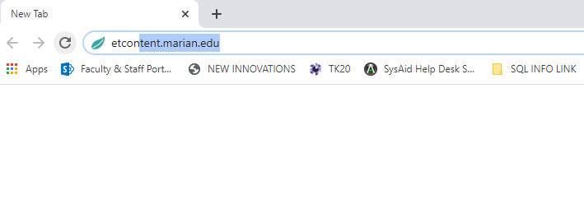

1. Use you Marian issued credentials to log in.

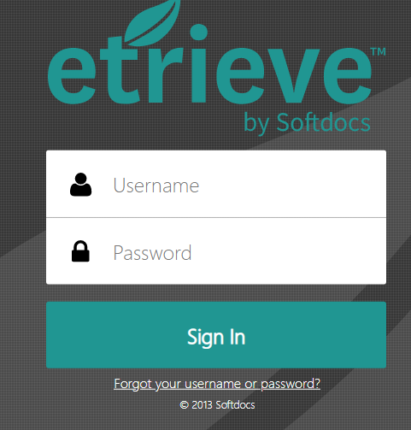

1. Use the search feature to type in the name of the student you wish to search. When you type in the student name it should populate all matches. Double click on the specific student you would like to access.

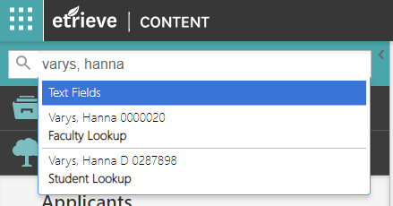

1. The “Tree” of documents will populate. **Select the “Students” option if it is not already selected.** You can use the drop-down arrows to navigate through the available documents.

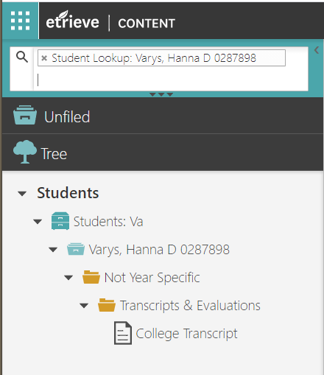

1. To navigate to a new student, return to the search box.
2. **NEVER LEAVE YOUR ETRIEVE BROWSWER OPEN – YOU MUST LOG OUT AFTER YOU HAVE COMPLETED YOUR SEARCH/REVIEW.** This will allow others to enter with our limited licenses we are currently operating with.
3. To log out, go to the upper right-hand corner of you screen and click the arrow beside your name. It will drop down, and you will click the “sign out.”

